## Case Publication from ACM to DSA – User Story

Epic: As a System, the completed cases are published back to DSA through a daily batch

Below is the high-level process for publishing the case from ACM and consumption by DSA.

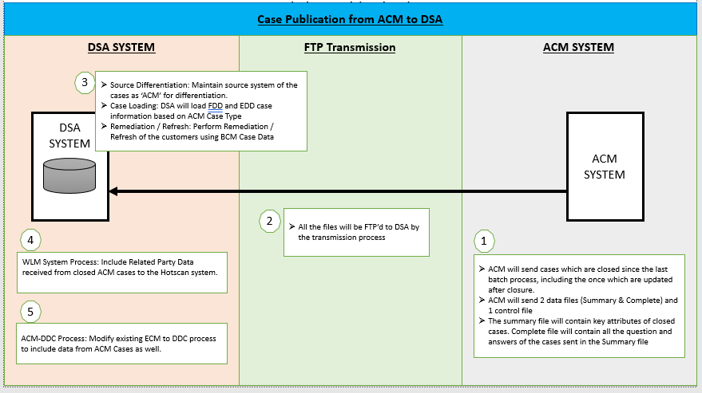

1. ACM will send **only** the cases which are fully investigated or closed (including updates made to such cases) to DSA every day, for the cases worked till the previous day.
2. ACM will send 2 Data files (Summary & Complete) and 1 Control File. Published Data will have the following information:
   1. Summary File: General Information about the case
   2. Complete File: Questions & Answers for each of the case
   3. Control File: Count of Records in Summary and Complete File
3. DSA will house this information and show on the KYC UI.
4. EDD & EDD LOW-MOD Cases published by ACM would follow the ACM specifications and guidelines.

Summary File - Key Points

Summary File will have the basic information for each of the cases created on ACM Application on the previous day, till the file generation time. Refer the *Appendix* for File Consumption time, Layout and field elements of the Summary file. Below is an extract of few key elements from the Summary File.

* + **Case Status:** Following are the possible values of the Case Status; As ACM will send the cases to DSA, only after the case is completely investigated or closed. So, DSA will receive only two statuses - **Investigation Complete and Closed.**
    - **Open**
    - **Closed**

*Note:*

*Cases in Open status on attaining a publishable disposition will be published with status - Investigation Complete*

*Case on closed will be published with ‘Closed’ status.*

* **Disposition Status:** List of possible Disposition Status for each of the Status (Investigation Complete & Closed) is available at Appendix.
* **Legacy Case ID:** ACM system will not be publishing any previous cases (BCM / ECM Cases)

(All migrated cases will be available in Historical Case DART View, wherein the investigator will be able to view the cases but will not be able to work on these cases. Hence Case publication will not include any previous system cases)

Complete File - Key Points

Complete File will have all the questions and their values for all the cases that exist in the Summary File. The questions follow a certain hierarchy defined at both ACM and DSA.

ACM Question Hierarchy

* + Category: This is topmost level. Equivalent to ‘Section’ of DSA-ECM Interface.
  + Requirement: This is third level. Equivalent to ‘Group’ of DSA - ECM Interface.
  + Repeat Id: This will be running number. If the container repeats, this indicates order of the container. E.g. If the case has two controlling party, the repeat id 1 indicates it is associated to CP1 and 2 indicates it is associated to CP2. This information will be used to display the questions together on the KYC Profile.

File Layouts & Key Fields

* 1. A question will have only one defined structure / hierarchy, which means a given question, can NOT have more than 1 Category / Section / Requirement or Description.
  2. DSA will configure the hierarchy for all the EDD and FDD Questions, with the respective Category / / Requirement and Description.
  3. DSA will receive only the Question ID and the corresponding response for each question as part of the ‘Complete file’. DSA will utilize configuration (Point #b above) to retrieve the question hierarchy for display on the KYC Profile.
  4. Question IDs not configured on DSA will be ignored and will not be available on the KYC Profile (incl. the Adobe PDF).
  5. ACM Questions will be Alphanumeric, but will NOT be prefixed with the text ‘Question’ (Unlike ECM Questions).
  6. ACM will carry the same drop down values for the questions as that of BCM/ECM for both EDD and FDD case type.
  7. EDD / FDD Questions:
     + ACM has NOT introduced any new questions for EDD and FDD respectively, However few of the existing Question have been removed; DSA will configure and will not account the deleted Questions for ACM interface. *(Note: DSA will not remove them for existing BCM Interface.)*
     + For few of the ECM EDD Questions, ACM has configured multiple Question IDs. On an ideal business scenario, only 1 of the ACM question ID will be available on the DSA Publication file; however, assuming DSA receives more than 1 Question IDs (mapped with the same ECM Question ID), DSA will check the fields sequentially and will utilize the first value encountered.
     + EDD/FDD Questions will not carry any Section ID. (No Section in ACM)
     + *Refer* *Appendix* *for EDD and FDD Questions, along with their respective hierarchy.*

Duplicate cases

ACM will flag the case as duplicate if investigator is working on any other EDD case for the same customer. For such cases, ACM will publish the case to DSA with **Status** as ‘Closed’ and **Disposition Status** as ‘Confirmed - Duplicate'. Duplicate case will not remediate / refresh customer in DSA. *(The disposition status ‘Confirmed - Duplicate' is associated with the status ‘Closed’ and will NOT be published with the status ‘Investigation Complete’ to DSA.)*

***Files, Field Mapping & Samples:***

1. *Refer to the* *Appendix* *for the files exchanged between DSA and ESB/ACM, and the file format which describes the fields, nature of the fields and their possible values.*
2. *Samples for all the files are provided at* *Appendix**. These files are mocked up manually and may not represent the accurate mapping / data and are shared only for a high level understanding of the process.*

# Appendix

|  |  |  |  |
| --- | --- | --- | --- |
| **Sr. No.** | **Section** | **Remarks** | **Files** |
| 1 | Case Lite, Update & Consumption Files | * Files exchanged bet. DSA and ACM (File Name & Schedules) * File Layout and Field Mapping |  |
| 2 | EDD / HRR Questions | * ACM EDD Questions * STAY and REMOVE Question List |  |
| 3 | FDD Questions | * ACM FDD Questions * STAY and REMOVE Question List |  |
| 4 | Status & Disposition Status | * List of Disposition Status * DDC Qualifying Disposition Status * Suppression Exception Qualifying Disposition Status |  |